Cameron Ball
Audience Awareness Exercise
Explaining the Cochlear Implant

Audience Profiles:
- 1st grader
- Roommate Teresa
- Grandfather, age 80
- Peer in selected field
- Audiology expert

1st grader
The first grader wants to know how the cochlear implant affects the people he or she knows. The 1st grader is assumed to have no background knowledge, and a very limited capacity to store and process information. I will deliver the information as a story with pictures and very few words. My goal will be to make the 1st grader aware of the fact that some people are deaf, and that the cochlear implant can help them to hear better and allow them to function normally in social situations.

Roommate Teresa
Teresa is my roommate. She is a junior at Washington University studying French and Italian. She is well educated, but has no background in mathematics or engineering at the college level. As such, I can assume that she understands the value and human impact of a cochlear implant. Teresa simply wants to understand how the device works. I will communicate the information using pictures and informal words and will use analogies to convey technical information.

Grandfather, age 80
My Grandfather is an 80-year-old Australian. The ex-Chief Justice of the Australian judiciary, he is thoroughly educated in logic and the English language. He enjoys new technology when it is nonthreatening. Nevertheless, he dislikes math. I will use a respectful tone with him, and introduce the implant as a way of restoring a person’s dignity and voice. This, I think, will interest him.

Colleague
The colleague has a college education in Biomedical Engineering, and is thus a peer. He or she understands ear physiology and the fundamental mathematical concepts needed to understand how the cochlear implant works, and is thus interested in a technical introduction to the implant.

Audiology Expert
The expert has a large knowledge base and is very technical. I will use a technical, professional tone, and address a key area of the implant that might be considered for further improvements, stating why it must be improved and how that may be achieved.

1st Grader—The Office Storybook—Jim Hears

Roommate Teresa

Hey Teresa! Here’s a bit about the cochlear implant. You asked me about it earlier today. Let me know if anything is unclear. We can talk about it over dinner (am I still cooking tonight?).

The cochlear implant is a medical device that helps the deaf recover hearing. The ear works by taking vibrations in the air (caused by a speaker, your mouth, etc.) and converting those small vibrations into electric signals. The brain, like a very advanced computer, can process these signals into what we perceive as sound. The cochlea is the part of the ear that converts mechanical vibrations into electrical information.

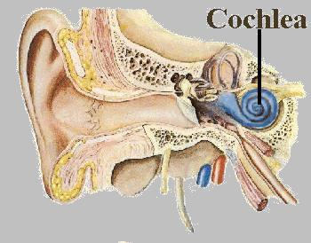

The cochlea’s interior is filled with fluid and lined with tiny hairs. Mechanical waves in the air cause a small bone in the ear to beat the cochlea like a drum, thus vibrating the fluid inside. The vibrations move along the spiral-shaped cochlea, wiggling the tiny hairs. When the hairs move in response to sound waves, they act like switches, turning on and off electrical signals. These signals run through nerves to the brain, and thus we can listen to music and hold conversations. Different frequencies of sound activate different regions of the cochlea. A song sung by a high pitched soprano moves different hairs than that sung by a low baritone. This spatial encoding stops us from hearing in monotone. As an analogy, the ear can be thought of as a piano. Mechanical vibrations from our fingers (sound waves) cause the keys to move (like little hairs, each having its own frequency associated with its position). The moving keys cause the sound to move down strings (nerves), and our brain interprets the output of the string vibrations as music. In some individuals, the cochlea’s hairs do not work well (like a piano with no keys). They cannot provide enough electricity for the nerves to relay the message to the brain. Hearing impairment may be so bad that individuals become deaf.
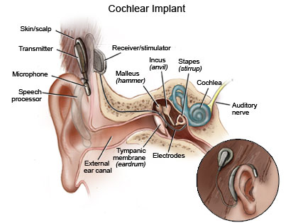

The cochlear implant cures this deafness. A microphone picks up sound from the surroundings, converting vibrations to electrical signals like the cochlea does. A tiny processor takes the electrical information and separates the sounds into frequencies using advanced mathematics. Now that the sound is in electronic format and categorized by frequency, it must be conveyed to the brain. The cochlear implant transmits the information from the processor to a wire that is surgically implanted in the user’s head. The wire is inserted into the cochlea and runs along its length.
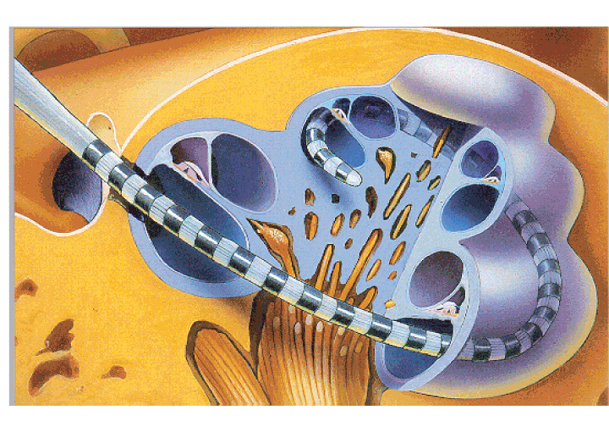
There are many electrodes (electricity emitting devices, shown above as dark blue bands) along the implant. Each one receives information from a different group of frequencies, and is thus analogous to a set of keys on a piano. When information arrives at an electrode, the electrode emits a burst of energy strong enough to excite nearby auditory nerves, and the brain can detect the sounds once more. Of course, this is a crude process: a few dozen electrodes cannot capture the same amazing sound quality that millions of properly functioning hairs could. Nevertheless, the cochlear implant works remarkably, and thousands of individuals have benefitted from this technology.

80-year-old Grandfather

Dear Granddad,

Thank you for your thoughtful and kind letter. I definitely enjoyed my brief stay in Hong Kong, especially because of your advice on where to go and what to see. The city is so fascinating! I am already planning my next trip. We’ll see if Mum wants to come along. Perhaps we could meet up with you and Grandma during your next session with the high court.
For now, I am occupied with my studies. You expressed interest in reading about what it is that I’m learning. Currently, I am fascinated by neural prosthetics—devices that interface with the brain, helping the blind see and the deaf hear. The use of technology to replicate hearing is particularly fascinating.
Deafness can greatly compromise an individual’s ability to communicate effectively in daily life. Not only does it impact hearing, but it also cripples speaking. A cure for deafness seems more miracle than medicine, but a cure—founded on principles of engineering and human physiology—does exist. The cochlear implant is a medical device that restores basic auditory function to individuals with extreme hearing loss. It has restored hearing to hundreds of thousands, and new models continue to improve upon past success. But how does the cochlear implant work? First one must understand how the ear naturally functions.
The ear takes vibrations in the air (your voice, noise from a jet, etc.) and converts those small vibrations into electrical signals that the brain can process into what we perceive as sound. The cochlea is the part of the ear that converts mechanical vibrations into electrical information.
The ear can be thought of as a musical instrument: a piano, for example. The cochlea is filled with fluid and lined with tiny hairs. Mechanical waves in the air oscillate a small bone that taps on the cochlea, vibrating the fluid inside. The vibrating fluid, like a pianist’s fingers, moves along the spiral-shaped cochlea, wiggling the tiny hairs like keys on a piano. When the hairs move in response to sound waves, they act like switches, turning on and off electrical signals. These signals run through nerves (the piano’s strings) to the brain, and thus we can listen to music and hold conversations.
Different frequencies of sound activate different regions of the cochlea. A song sung by a high-pitched soprano agitates different hairs than that sung by a baritone. This “spatial encoding” of pitch occurs on the piano as well; each of the keys, like little hairs, has its own frequency associated with its position. In some individuals, the cochlea’s hairs do not work well, like a piano with jammed keys. The hair cells cannot provide enough electricity for the nerves to relay the message to the brain. Hearing impairment may be so bad that individuals become deaf. This is where the cochlear implant intervenes.

The cochlear implant cures this deafness. A microphone picks up sound from the surroundings, converting vibrations to electrical signals, much like the cochlea. A tiny processor (small computer) takes the electrical information and separates the sounds into frequencies using advanced mathematics (some of the math still hurts my brain). Now that the sound is in electronic format and categorized by frequency, it must be conveyed to the brain. The cochlear implant transmits the information from the processor to a wire that is surgically implanted in the user’s head. The wire is inserted into the cochlea and runs along its length.
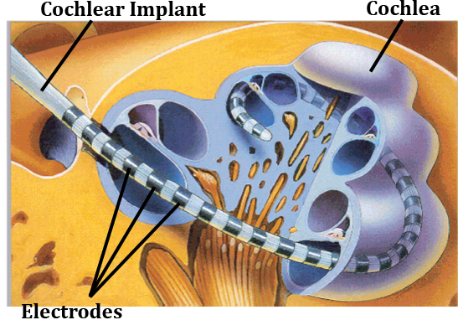
There are many electrodes (electricity emitting devices, shown above as dark blue bands) along the implant. Each one receives information from a different group of frequencies, and is thus analogous to a small set of keys (or a chord) on a piano. When information arrives at an electrode, the electrode emits a burst of energy strong enough to excite nearby nerves. The brain responds, and hearing is restored. Of course, this is a crude process: a few dozen electrodes cannot convey the same level of complexity that millions of properly functioning hairs could. Nevertheless, the cochlear implant works remarkably, and thousands of individuals have benefitted from this miraculous technology.
Biomedical Engineering offers me a means of combining my passions for technology and humanity. The cochlear implant and other neural prosthetics like it are wonderful examples of how I might apply my knowledge to restore dignity to individuals.
I’ll be looking forward to seeing pictures from Paul’s wedding. Wish him the best for us!

Much Love,
Cameron

Colleague
The cochlear implant is a medical device that helps the deaf recover hearing in cases where the hair cells in the organ of Corti are damaged. A microphone digitizes sound, which is then sent to a processor at high sampling rates (recall that sampling theory requires that we acquire data at a rate at least twice that of the highest significant frequency component in the signal). The processor performs a Fast Fourier Transform (FFT) operation on the signal to decompose the signal into frequency components.
We can then bin the signal according to frequency using multiplication in the frequency domain (in the time domain, signals would have to be convoluted with their filters, which is computationally expensive), with the number of bins determining the level of resolution provided by the implant. Binning signals by frequency is necessary to mimic the unique, elegant spatial encoding naturally found in the cochlea. At the cochlea’s base, the cochlear partition is stiff and narrow. At the end of the cochlea (moving away from the oval and round windows), the partition is broad and thin, making it more flexible. We can apply standard biomechanics techniques to work out what implications this geometry has for frequency tuning. Because the stiffness of the partition changes, so does its resonant frequency. The resonant frequency of the cochlea shifts to lower frequencies as distance from the oval window increases. The basilar membrane thus acts as a band pass filter (part A of figure below), whose magnitude is greatest at the damped natural frequency of the system. Binning signals into frequency bands attempts to do the same.
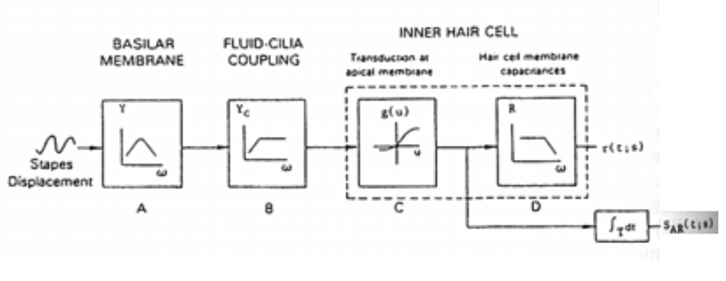
The stimulating portion of the implant consists of a wire running through the cochlea with a number of electrodes along the length of the probe. These stimulating electrodes produce a voltage to replace the electrical stimulating abilities of the dead hair cells, triggering auditory nerves in the region of the electrode. Electrodes are stimulated when a signal of the correct frequency is detected and processed. The brain modulates and sums these nervous action potentials to reproduce speech. The brain quickly adapts and tunes the frequency information delivered by the implant.

Expert—pdf of Fake Journal Article

